Draft of Proposal on the Nomination of

Lesser Sunda as Priority Seascape

April 2018

TABLE OF CONTENTS

Background 3
Overview of Lesser Sunda 3
Criteria of the Designation of Lesser Sunda as Priority Seascape 5
- Ecological, Biological, and Economic Significance of Lesser Sunda 6
- Connectivity Significance of Lesser Sunda 8
- Pressure and Threats 11
- Political Will, Governance, Stakeholders Collaboration and Opportunity 13
- Regional Coordinating/Governance Mechanism of Lesser Sunda 16
- Global/Regional Benefits of Lesser Sunda 18
- Available Data and Information 20
Conclusion and Recommendations 21

Draft of Proposal

on the Nomination of Lesser Sunda as Priority Seascape

Background
The Regional Plan of Action of Coral Triangle Initiative for Coral Reefs, Fisheries and Food Security (CTI-CCF) translated the high-level political commitments of six Coral Triangle countries into a single sustainable management plan of action. The plan was developed around five explicit goals, namely: (1) “Priority seascapes: designated and effectively managed, (2) Ecosystem approach to management of fisheries and other marine resources fully applied, (3) Marine Protected Areas established and effectively managed, (4) Climate Change Adaptation measures achieved, and (5) Threatened species status improved.

Goal 1 of the RPOA, “’Priority Seascapes’ Designated and Effectively Managed”, directs CTI-CFF countries to prioritize large-scale geographies for investment and action and expand the use of best practices in these areas. Under this Goal, the first target includes ‘Priority Seascapes Designated, with Investment Plans Completed and Sequenced’. The Sulu Sulawesi Seascape was the first and only Priority Seascape already endorsed. Subsequently, the 13th CTI-CFF Senior Officials Meeting (SOM) held in Manila on 29-30 November 2017 had endorsed the decision to nominate Lesser Sunda and Bismarck-Solomon Sea Ecoregion (BSSE) as priority seascapes.

Based on the Seascapes General Model and Regional Framework for Priority Seascapes, the designation of a particular seascape can only be formally endorsed and adopted by CTI-CFF Committee of Senior Officials (CSO) and reported to Council of Minister (COM) only if it is jointly proposed by the concerned countries. Although during SOM-13 all relevant countries (Indonesia, Timor Leste, PNG and Solomon Islands) have officially supported the designation of Lesser Sunda and BSSE as priority seascapes, it was also agreed that prior to jointly announcing both seascapes in the upcoming SOM-14, there is a need to prepare the data, information, and justification to support nomination, as well as to discuss strategic priorities and potential cooperation activities under the two seascapes.

The following information aimed to provide justification from Indonesia’s perspective as to why Lesser Sunda should be nominated as priority seascape in accordance with the criteria outlined on the document of Seascapes General Model and Regional Framework for Priority Seascapes. This document then should be enriched and integrated with information from Timor Leste’s perspective for the two countries’ further consultation and discussion, in order to provide a comprehensive proposal for the nomination of Lesser Sunda as priority seascape.

Overview of Lesser Sunda
As can be seen in Figure 1., the Lesser Sunda is located in the southwestern part of the Coral Triangle, covering the waters of two countries: Indonesia and Timor Leste. It encompasses the chain of islands from Bali in the west to Timor Leste in the northeast along the Nusa Tenggara Islands, also to the south of Sumba and Rote Islands and covers a marine area of 35,802,039 hectares and 10,886 kilometers of coastline (Green and Mous, 2008). It sits at the crossroads of the Indian and Pacific Oceans, and has a combination of unique conditions — including channel depth, currents, and temperatures — make this an extraordinarily rich hub for marine life.

The Lesser Sunda region has 1,056 islands, in which most of them are small islands. The main Lesser Sunda Islands are Bali, Lombok, Sumbawa, Flores, Sumba, Timor, Alor archipelago and Wetar Islands. The islands are part of a volcanic arc formed by subduction along the Sunda Trench in the Java Sea, known as the Sunda Arc.

Administratively, in Indonesia, the Lesser Sunda region spans over 4 provinces, including Bali, West Nusa Tenggara, East Nusa Tenggara, and Maluku. Within these 4 provinces, there are 41 districts and a total population of 13,812,302 (BPS, 2014). Approximately 11,740,457 people (85%) live on the coast (LAPI ITB, 2017). Most have land-based livelihoods but for the coastal community, the ocean provides a primary source of income. They also farm seaweed, grouper, salt, milkfish and pearls. A small portion works in the tourism sector, acting as guides for such activities as sport fishing, diving, snorkeling and surfing.

Figure 1. The region of Indonesia’s Lesser Sunda

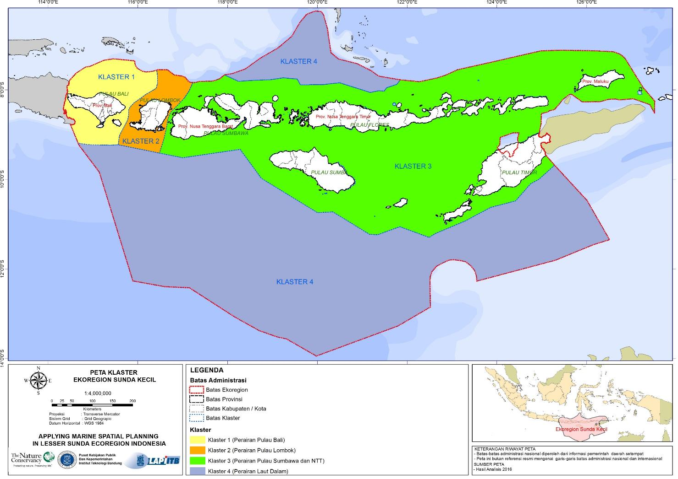

Criteria of the Designation of Lesser Sunda as Priority Seascape

In the document of Seascapes General Model and Regional Framework for Priority Seascapes, there are several criterias on the designation of CTI-CFF priority seascapes:
- Each Priority Seascape demonstrates high values that bind and give purpose to the seascape. The specific high values of a Priority Seascape include at least three of the following:
  - Ecological significance (Examples: EBSA, KBA, migratory routes, nesting sites for sea turtles, etc.)
  - Biological productivity
  - Economic (Existing or potential)
  - Cultural / heritage values
  - Resilience

- Demonstrates significant connectivity within and outside the Priority Seascape in at least three out of the following ways:
    - Biological
    - Socio-Cultural
    - Institutional (local government networks, official or unofficial)
- Economic

- There must be sustainable economic and/or other human activities overlapping with and adding pressure/potential threats on the high values. (This is the justification for triggering the creation of a Priority Seascape.)

- The following key enabling factors are present:
  - Political will
  - Governance
  - Stakeholder support, engagement
  - Opportunity (This may include collaboration and partnership, financial support, etc.)

  - A political and/or institutional enabling coordinating/governance mechanism is present (newly initiated or existing) in order to move the process of creating a seascape forward.
Examples of enabling coordinating/governance mechanisms: Bilateral formal cooperation, treaties, Memorandum of Understanding, international agreements, CTI-CFF, CTI-CFF Sub-group, project, etc.

  - Priority Seascapes should have and contribute to the regional and/or global benefit of the CTI. The regional and/or global benefit of a specific Priority Seascape can come from a wide variety of factors including:
- Ecological Factors
  - Social and Cultural Factors
  - Economic Factors
  - Biological representation
  - Regionally unique or significant phenomenon
  - Geographic representation

- Priority Seascapes have data and information available and accessible for decision making.

Aligning with the above criteria on Priority Seascapes, the following description reflects the information of Lesser Sunda in Indonesia’s region with highlights on some aspects.

1. Ecological, Biological, and Economic Significance of Lesser Sunda

In the Indonesian part of Lesser Sunda, around 523 species of coral have been recorded here. Eleven species are endemic. Lesser Sunda coral represent 76% of all reef building coral species (Veron et al., 2009). Twenty-two species of marine mammal (cetacean) are recorded in the Lesser Sunda. These include seven dolphin species, 14 whale species and one dugong species (Kahn, 2013). The resident populations of dugong and sperm whale species are listed as vulnerable on the IUCN Red list of threatened species. The locally present blue whale is considered endangered (IUCN, 2016). Lesser Sunda is also home to 17 other globally threatened marine species. This statistic includes turtles, fish, mollusks, sea birds, 176 species of corals and 10 species of sea cucumber. Most of the species are also in Appendix I and II of CITES (Table 1).

Lesser Sunda has approximately 25,901 hectares of mangrove forest (GeoEye 2011 & Rapid- Eye 2014). Mangroves act as a nursery for juvenile fish. These ecosystems also provide people with shrimp and crab to eat and protection against waves and tides. There are at least 15 species of mangroves in Lesser Sunda. There are also 10 recorded sea grass species distributed over 56,414 ha. Seagrasses are habitat for dugongs and turtles. They are also sources of food for fish and crustaceans. There are 78,975 ha of coral cover in the Lesser Sunda. The coral in the Lesser Sunda are home to 350 species of fish. It offers a number of ecosystem services such as a barrier to waves and abrasion for coastal villages. It also draws tourists interested in snorkeling and diving.

Table 1. List of species in Lesser Sunda and the protection status
According to IUCN, CITES and Govt Reg No. 7/99

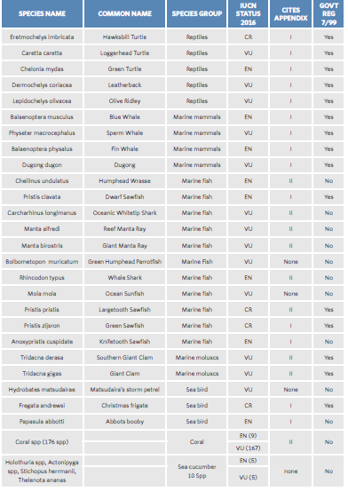
Note. VU: vulnerable, EN: endangered, CR: critically endangered
Source: Burung, 2014 and Kahn, 2013
A unique mix of deep channels, currents and cool water temperature give the area the ideal conditions for marine upwelling. The mixture of cold, nutrient- rich, deep-sea water with the warm, surface water allows plankton to thrive, creating a robust base to the local food chain. The Savu Sea pelagic fish fishery is an estimated 156,000 ton/year (Indonesia), with a realized catch of 65,331.5 ton (41,88 %). Demersal fish is estimated at 84,000 ton/year (Indonesia) with a realized catch of 17,778.7 ton (21.17%) (TNC, 2015a). Commercial fish species such as snapper, grouper, parrotfish, tuna, barracuda, rabbitfish and trevally fill local fishermen’s nets or auction houses. Although the islands are sparsely populated, they are home to millions of people who depend on the sea for their livelihood.

In the Savu Sea’s Kupang, Rote Ndao and Manggarai districts, more than a thousand head of households rely on the ocean. Most of them fish daily at 12 miles or less from shore. Some, but not all, have boats with motors. For these coastal villagers, the ocean is not only a source for fish. People
in the area farm seaweed and the production was 891.4 ton in 2005. They raise fish in floating net cages (KJA, keramba jaring apung) and the production of caged fish in 1998 reached to 2,001 ton (TNC, 2015a). The area also holds 73% of Indonesia’s fish exports, making it the biggest source of exported fish in Indonesia.

Furthermore, a growing portion of population is starting to realize the tourism potential as a source of income in the area. As a result, some communities are now engaging in the tourism sector, mostly acting as guides for activities such as sport fishing, sightseeing, diving, snorkeling, and surfing. Many locations in Lesser Sunda such as Bali, Lombok, Komodo Islands, Riung Islands, Maumere, Rote and Alor, have developed marine tourism industries. Forty percent (40%) of international tourists coming to Indonesia are bound to visit Lesser Sunda islands (LAPI ITB, 2017). Consistent sightings of cetaceans in East Nusa Tenggara waters could provide coastal communities with a valuable opportunity to establish new eco-ventures such as responsible whale and dolphin watching.

2. Connectivity Significance of Lesser Sunda

The Indonesian through flow serves not only as sea lane for transportation but also plays ecological role as main passageways for many marine organisms. The constant water movement provides continuous planktonic supply around the areas. As Figures 2 demonstrates, observation on current pattern in West Nusa Tenggara (Yulianto et al, 2015) showed that although there are two main current patterns that connect east and the west at northern and southern coast, there is still water current movement across northern and southern waters through small straits between islands which secure plankton supply for this region. This study solidifies the feature of Lesser Sunda for its resilience to climate change.

Figure 2. Water current pattern in West Nusa Tenggara during west season (a), transition I (b), east season (c), and transition II (d)

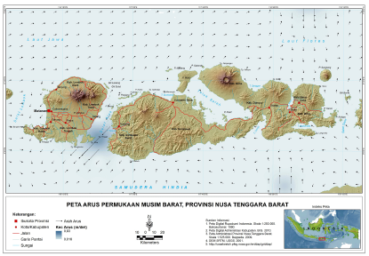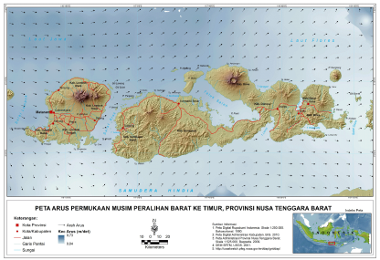
(a) (b)
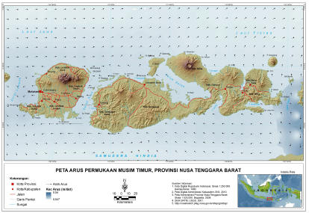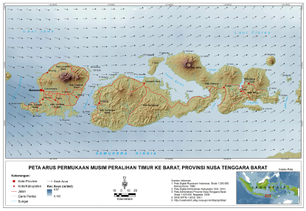
(c) (d)

In addition to water current pattern, the region also connects a number of marine corridors as migration routes. Lesser Sunda plays important role as migration corridors for both great whales and oceanic dolphins and ranked as first priority for cetacean. The region serves not only as migration corridors but also as foraging habitat and calving area especially for Savu Sea. Solor Alor, Atauro, Inner Banda Arch and Outer Banda Arch form continuous corridors for cetacean migration between Banda Sea and Savu Sea (CEPF, 2014). Additionally to cetacean, the region is also one of migration routes for sea turtles.

Protecting ecosystem, such as coral reef, seagrass and mangrove in the designated seascape is vital to existence of marine biota that living within it. Although, coral reef is known to be the key habitat to protect the coral reef fish, mangrove also has an important role to enhance the biomass of the coral reef fish (Mumby P.J et al, 2003). Moreover, seagrass ecosystems also have important roles as a source of primary productivity and a foraging and nursery ground for several of marine biota (Erftemeijer et al. 1993; Christianen et al. 2014). Lesser Sunda eco-region has the highest biological diversity in the world and habitat for 76% coral reef species and 2,631 reef fish species. The steep underwater landscape and upwelling-driven productivity provide a unique habitat for resident and migratory large marine fauna such as whales, dolphins, dugongs, sharks, turtles and manta rays. It is also an important migration path for several of the cetacean species and six sea turtle species from the Indian Ocean to the Pacific Ocean.

Figure 3. Marine corridors in East Nusa Tenggara, Timor Leste, and Maluku
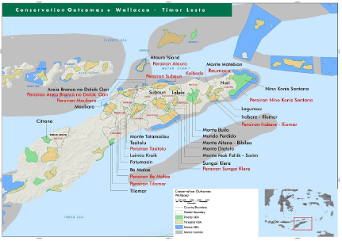

Rapid ecological assessment conducted by TNC between 2013 and 2015 revealed that there are 22 species of cetacean in the Lesser Sunda Ecoregion, and that the cetaceans in the Savu and Banda Seas, Raja Ampat and Timor Leste may be genetically related to cetaceans in Papua New Guinea and Solomon Islands. This finding suggests that the area is important for both migratory and resident whales in the Coral Triangle region.

Despite the ecological importances of Lesser Sunda, local reefs and their associated ecosystems have long been threatened by destructive fishing, overfishing, pollution and coastal development. These threats are in addition to the impacts of climate change such as increased sea surface temperature, sea level rise, extreme weather and ocean acidification. Thus, creating networks of marine protected areas (MPAs) is a key to improving the ‘resilience’ of these ecosystems to climate change impacts (Figure 4). The total area of MPA network in Lesser Sunda is 7.56 million hectares, with several conservation targets as follow:
- 30% of each shallow marine habitat (coral reefs, mangroves, seagrass and estuaries) and its sub-class
- 50% of areas known to be important for dolphins
- 80 % of special and unique areas including confirmed turtle nesting and feeding areas and spawning aggregation sites for fish and shrimp
- 5% of areas identified as important to seabirds
- 5 % of large scale persistent pelagic habitats (e.g., upwelling), satellite islands, straits
- 100% of small areas identified as important habitat for rare and/or endangered species such as Napoleon Wrasses and sharks
- 5-80 % known distribution of cetaceans and dugongs in shallow coastal waters
- 80 % of of dive sites, since they are likely to be in coral reef areas that are still in good condition

Figure 4. The design of MPA Network in Indonesia’s Lesser Sunda
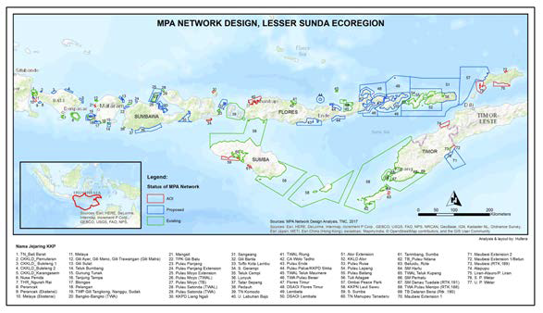

3. Pressure and Threats

Lesser Sunda region is increasingly exposed to destructive fishing, overfishing, pollution and coastal development. Deforestation has led to the clouding of coastal waters. Seismic oil and gas exploration and production have introduced underwater noise pollution. Construction associated with growing populations has brought urban and industrial waste. Frequent anchoring and grounding of tourist boats have damaged local reefs. Reef blasting has further degraded local habitat (Kahn, 2014). This region is now also threatened by climate change impacts including increased sea temperatures, sea level rise, extreme weather and ocean acidification.

Residential whale and dolphin populations, as well as migratory species at Lesser Sunda region in their long-range movements, may be increasingly vulnerable to numerous regional and local environmental impacts. Seismic surveys for seabed oil and gas exploration, potential strikes from increasing ship traffic, entanglement in fishing nets, increasing discharge of plastic pollution from urban areas and targeted catches by traditional whale hunters are the potential emerging threats to cetacean.

For generations, the high ecological value of marine resources in Lesser Sunda generates the economic value of these resources. It is often found the coral reef areas in Lesser Sunda were fished intensively and in a number of incidents involves destructive practices such as blast fishing and fish poison. Directorate of Marine Resources Surveillance has mapped the area where destructive fishing practices frequently occurred. As shown in Figure 4, where destructive fishing areas are also found in a number of areas in West Nusa Tenggara, East Nusa Tenggara, and further east to Tanimbar and Kei Islands shows indication on chain of destructive fishing practices along Lesser Sunda Region. Thus integrated and harmonized approach among regional governments on these areas is needed to combat these destructive practices.

Figure 5. Map of destructive fishing areas in Indonesia.
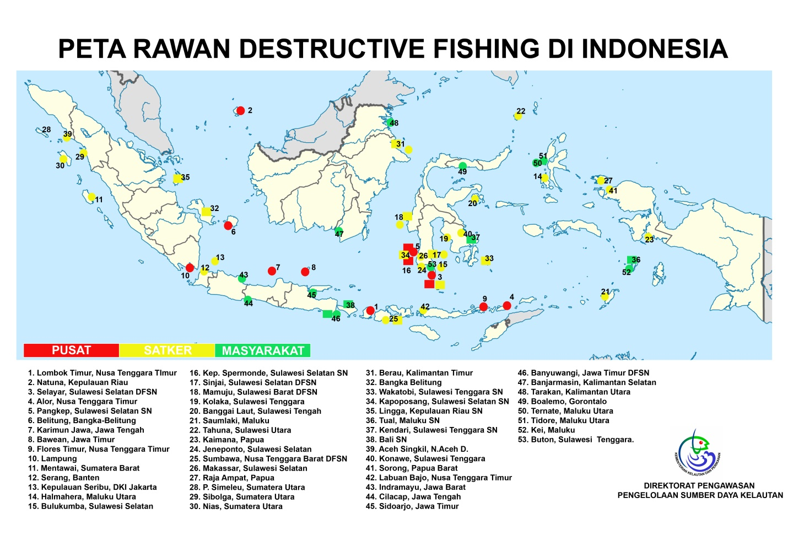

Threats could also emerge because of intensifying tourism activities. Many diving sites which contain a vast diversity of coral reef and fish are especially vulnerable to human intervention. For example, giving bread crumbs to fish while snorkeling could be considered as harmful to the fish. Similar thing could be said about the elasmobranch existence in the area. Manta rays and whale sharks could be stressed out by the presence of people that are not aware about the condition that they must set limit to. Therefore, it is imperative to create a responsible tourism activity to prevent such things from happening. Local and provincial governments, NGOs, as well as marine tourism operators, have already expressed interest in developing a responsible whale watching industry in East Nusa Tenggara. The sector should be developed alongside operator-endorsed codes of conduct and appropriate regulatory frameworks, including the establishment of Marine Protected Areas or MPAs.

4. Political Will, Governance, Stakeholders Collaboration and Opportunity

Indonesia fulfilled its commitment to the Convention on Biological Diversity’s Program of Work on Protected Areas to create 10 million hectares of Marine Protected Areas (MPAs) in 2010, with the declaration of the 3.35 million hectare Savu Sea Marine National Park within the Lesser Sunda Ecoregion. The Government of Indonesia has demonstrated its commitment to establishing a regional network of MPAs through its leadership in the Coral Triangle Initiative.

In developing seascapes in Indonesia, Government of Indonesia is intended to use Marine Spatial Planning (MSP) as a tool for achieving comprehensive planning within the seascapes under Indonesia’s jurisdiction. Following the implementation on the design of a resilient network of Marine Protected Areas in the Lesser Sunda (Wilson et al., 2001), Government of Indonesia produced a comprehensive document of Lesser Sunda MSP that integrates the existing and future government plans, including conservation and economic development. This document provided guidance for future sustainable economic investments and development throughout the Lesser Sunda ecoregion. MSP in Lesser Sunda ecoregion is designed to allocate space on marine resources usage for the welfare of the communities (Kombaitan et al., 2017). Exercising a conservation approach, the eventual zoning scheme will balance conservation objectives and economic interests of the fisheries, tourism, and mining sectors. With political, institutional, and technical support, it is expected that Lesser Sunda MSP can be a national showcase for effective management of marine space and resources.

The CTI-CFF Seascapes General Model and Regional Framework for Priority Seascape has correctly identified stakeholders’ support and engagement as one of important key enabling factors that should exist in the area for a seascape to be designated as priority. Local communities, especially coastal communities, are inevitably a crucial stakeholder as they are expected to have access to and sustainably use the natural assets accrued from coastal marine systems as part seascape. Therefore, community-based management leading to effective management of coastal community fisheries and local implementation of managed access and reserves (MPA in its loose form) is very important. RARE’s experiences in generating and sustaining positive desired behavior of coastal communities in several villages at Lesser Sunda’s MPAs, i.e. Bumbang Bay Marine Tourism Park (Central Lombok District), Gili Matra MPA (North Lombok District), Komodo Marine National Park (Manggarai Barat District) and Nino Konis Santana National Park (Lautem District, Timor-Leste) have resulted in higher compliance to MPA zoning and sustainable fishing regulation (gears, size and time), stable and better biophysical-ecological state (hard coral cover, fish biomass) and higher social cohesiveness and resilience.

Options for funding opportunities are also available for Lesser Sunda seascape. One of several possible sources for of financial supports that can be explored is the Government of Australia as it has given assistance to CTI-CFF Seascape Working Group for years. Indonesia and Timor-Leste may consider of conducting initial approach to Australian government to invite its role in following up some initial works including the materialization of the CTI-CFF Seascapes General Model and Regional Framework for Priority Seascape (that Australian government has supported) through the establishment of Lesser Sunda priority seascape. Other sources of funding opportunities exist as can be seen in Table 2.

Table 2: Selected Grant Opportunities for Lesser Sunda Priority Sescape Funding

NO | NAME OF ORGANISATION | NAME OF GRANT | DESCRIPTIONS
1 | The Ocean Foundation | Ocean Initiatives | Ocean Foundation supports, strengthen, and promote those organizations dedicated to reversing the trend of destruction of ocean environments around the world  Our Coral Reef Initiative provides grants to projects that focus on better management of fisheries and tourism development, development of sustainable coral reef products, establishment of marine reserves, and scientific research that can lead to new breakthroughs in medicine and biotechnology.
2 | - Leonardo D'Caprio Foundation  - Google  - Oceania  - Skytruth | Global Fishing Watch | Global Fishing Watch enables anyone with an internet connection to see fishing activity anywhere in the ocean in near real time — for free. The grand ambitious work is currently under development and compiling information from various stakeholders. CTI-CFF can be part of:  - Sharing existing database of CT6 member states  - Collaboration to help manage CT Atlas / CT Maps
3 | Joint programme by the following Organizations:  - Indonesia Waste Platform  - World Bank  - Coordinating Ministry of Maritime Affairs  - DANIDA  - UNDP | Not yet published | http://www.oceanactionhub.org/oceans-fish-not-plastic-undp-indonesia  Indonesia Waste Platform  http://www.indonesianwaste.org/en/home/
4 | KfW Germany | Blue Action Funds | Conserving the world’s oceans and stopping the loss of its biodiversity are among humanity’s biggest challenges. Blue Action Fund contributes meeting this challenge by supporting national and international non-governmental organizations in their efforts to conserve oceans and coastlines, by promoting:  - The safeguarding of marine biodiversity: creating new protected areas and improving the management of existing ones.  - The sustainable use of marine biodiversity: in fisheries, aquaculture and tourism
5 | KfW Germany | Trust Fund or Endowment Fund | KFW is a German Development Bank that provides support for development related programmes and for some cases - Trust Fund - for environment / conservation work
6 | Athelia Ecosphere | Sustainable Ocean Fund | Althelia announces it is to launch a Sustainable Ocean Fund designed to scale sustainable fisheries, build value in the seafood supply chain and finance marine and coastal conservation. In Sustainable Ocean Fund, Athelia Ecosphere is in partnership with CI and EDF (Environmental Defence Funds).  Conservation International and EDF are partners to the SOF providing technical expertise and project oversight.
7 | SIDA  (Swedish International Development Cooperation Agency) | Mangroves for the Future Project | Indonesia and East Asian countries are eligible to apply. SIDA has Asia office in Bangkok and maybe interested to support the gender mainstreaming capacity building aspect.
8 | World Oceans Council (WOC) | Corporate Ocean Responsibility | The World Ocean Council is fostering the development of regional ocean business councils to engage Members’ input to regional policy processes, science efforts, and the development of solutions to operational and technical issues at the regional level. Engaging the Ocean Business Community is paramount for the success of these initiatives and to ensure responsible, well-managed economic activities are part of the future of the regional seas. Areas of high priority continue to emerge, such as the Coral Triangle in South East Asia, which the WOC actively monitors and reports on to its Members and the Ocean Business Community.
9 | JICA | No information on regional program | JICA support development work to developing countries. JICA provides G to G assistance. Grants provided for CTI-CFF Pacific Member Countries in terms of education and capacity building (but on general sustainable livelihood and resilience issues)
Source: Project Initiation Specialist Deliverables for CTI-CFF Financial Resources Working Group Report in CTI-CFF Pre SOM Meeting, Manila, 27 November 2017 (adapted)

Several NGOs like The Nature Conservancy, World Wildlife Fund, Conservation International, and Wildlife Conservation Society have helped the Government of Indonesia in Lesser Sunda to demonstrate a practical application of ecosystem-based management – an integrated, sustainable management of the full suite of human activities occurring in large, spatially defined areas.

5. Regional Coordinating/Governance Mechanism of Lesser Sunda

Since Republic of Indonesia and Democratic Republic of Timor – Leste share Timor Island together, the two countries intertwined in various level from shared cultural history to official diplomatic relations. Until 2012, at least 58 agreements and cooperation letters have been signed between Government of Indonesia and Government of Timor Leste. Among those cooperation, there are at least 2 cooperation which highly correlated with marine and fisheries issue; [1] Letter of Intent between the Ministry of Marine Affairs and Fisheries of the Republic of Indonesia and the Ministry of Agriculture and Fisheries of the Democratic Republic of Timor Leste on Marine and Fishery Cooperation and [2] Memorandum of Understanding between the Ministry of Environment of the Republic of Indonesia and the Ministry of Economy and Development of Democratic Republic of Timor Leste on Environmental Cooperation.
The Coral Triangle Initiative (CTI) Plan of Actions is the manifestation of the bold and ambitious commitments made by the six CT countries in Manado in May 2009 to transform sustainable management of marine resources in the Coral Triangle (CT) region. This Plan of Actions encompasses six overarching goals, including a goal of designation and effective management of ‘priority seascapes’. The 13th CTI-CFF Senior Officials Meeting (SOM) held in Manila on 29-30 November 2017 had endorsed the decision to nominate Lesser Sunda as priority seascape.

Several steps need to be conducted to meet the procedures for trans-boundary Priority Seascapes designation, as suggested in the document of Seascapes General Model and Regional Framework for Priority Seascapes. Following the SOM13 decision, a future coordinating mechanism needs to be established, such as bilateral formal cooperation and treaties. To initiate this process, Indonesia hosted a meeting on the Establishment of Lesser Sunda as Priority Seascape in Jakarta on 20 April 2018. These efforts are expected to be starting activities in producing a form of coordinating and governance mechanism in the development of Lesser Sunda priority seascape.
Aside from the above mentioned bilateral cooperation instrument, Indonesia and Timor-Leste could formally request the CTI-CFF Regional Secretariat to give support to Lesser Sunda priority seascape planning and implementation. At SOM-13 in Manila on October 2017, numerous cooperation activities involving travel, MOU signing, discussion and exchange activities have been reported by Regional Secretariat to CTI-CFF Committee of Senior Officials. Some of them are collaboration with Timor-Leste-based universities. However, a much larger scope and context for cooperation with other stakeholders are very much open to explore as source for coordinating mechanism and project implementation under the framework of Lesser Sunda seascape priorities. Table 3 shows the many options of CTI-CFF cooperation with many organizations that Lesser Sunda can take advantage of.

Table 3: List CTI-CFF Regional Secretariat’s of Cooperation Partners in Up to 2017 for
Optimization of Lesser Sunda Priority Seascape Coordination Mechanism

No | CTI-CFF Regional Secretariat Cooperation Partners | Place and Date of Cooperation Instrument Signing or Event | Field of Cooperation
1 | Southeast Asian Fisheries Development Center (SEAFDEC) | Bangkok, Thailand 23-25 August 2017 | Sustainability and replication of fisheries management initiatives.
2 | Secretariat of the Pacific Regional Environment Programme (SPREP) | 22 September 2015 | Human resource development, research and development, consultancy and information management
4 | Deutsche Gesellschaft tur Internationale Zusammenarbeit GmbH (GIZ) | Quezon City, Philippines, 12-13 January 2017 | Learning from Sulu-Sulawesi priority seascape.
5 | Padjadjaran University (UNPAD), Indonesia | Bandung, August 18, 2017 | Marine environment, sustainable fisheries, and food security
6 | Universiti Malaysia Terengganu (UMT), Malaysia | Terengganu, 11-13 September 2017 | Artificial reef and related aquatic habitats
7 | The University of Papua New Guinea (UPNG), Papua New Guinea | Manado, 8 August 2017 | The framework of University Partnership
8 | Solomon Islands of University (SINU), Solomon Islands | No Information | Marine and coastal resource management including seascape management.
9 | Universidade Nacional Timor Lorosa’e (UNTL) Timor-Leste | Dili, 5-7 December 2016  Manado, 8 August 2017 | Coastal community development  Sustainable management of marine and coastal resources
10 | Univercidade Oriental de Timor-Leste (UNITAL) Timor-Leste | 13 March 2017 | Research, capacity building, marine and coastal sustainable management
11 | James Cook University (JCU), Australia | Canberra, 6-11 November 2017 | Nature research management, marine debris
12 | University of Queensland (UQ), Australia | Queensland, 16 September 2016 and Jakarta, 14 November 2016 | Research and innovation
13 | Universiti Malaysia Sabah Borneo Marine Research (UMS), Malaysia | Manado, 7-8 August 2017 | Capacity building
14 | University of the Philippines Diliman (UPD), Philippines. | Manado, around 28 February-1 March 2017 | Capacity building, research and outreach
15 | University of Maryland School of Public Policy | Manado, 10 January 2017 | Reef and fishery management and conservation
16 | Australian Consortium for ‘In-Country’ Indonesian Studies (ACICIS) | Jakarta, 11 January 2017 | Learning, living and studying experiences in Indonesia
17 | Program for the Environmental Management of the Seas of East Asia (PEMSEA) | Manila, 20 January 2017 | Cooperation
Source: Decision Document on CTI-CFF Regional Secretariat’s Cooperation Arrangement at the 13th CTI-CFF SENIOR OFFICIALS’ MEETING (SOM-13), 29 – 30 November 2017, Manila, Philippines and 2017 Activities Report of CTI-CFF Regional Secretariat, Manado, November 2017, both adapted.

6. Global/Regional Benefits of Lesser Sunda

Priority Seascapes should have and contribute to the regional and/or global benefit of the CTI. Lesser Sunda provides ecological and biological benefits, especially as it becomes the centre of biodiversity and endemism.

As it lies in the heart of coral triangle, Lesser Sunda has been identified as one of biodiversity hotspots in Indonesia since the beginning of 1990’s. Huffard et al (2012) ranked Lesser Sunda as third priority region for marine biodiversity conservation in Indonesia. It echoed what Roberts et al (2002) and Allen (2008) stated earlier that Lesser Sunda is in the top rank as marine hotspot for its marine biodiversity and endemism. Lesser Sunda is considered to be one of primary sources of global coral biodiversity and center of endemism. Physical features supporting high biodiversity in this region is constant water movement and strong seasonal upwelling of deep cold water. These two features provide supply of nutrient and guarantee the distribution throughout the region. It also suggests that the region likely resilient to climate change.

In 2014, Critical Ecosystem Partnership Fund (CEPF) was working to identify biodiversity hotspots in Wallacea region, a collaboration work between Burung Indonesia with Marine and Coastal Research Institute-Bogor Agricultural University, Samdhana Institute, Wildlife Conservation Society Indonesia Program, and Hametin Associates. The study was working to identify key species, Key Biodiversity Area (KBA), and biodiversity corridors as priority for conservation. Of 16 marine corridors identified in Wallacea, 8 of them interlinked between Lesser Sunda and Banda Region, namely (1) Timor Sea, (2) Savu Sea, (3) Solor Alor, (4) Outer Banda Arch, (5) Lombok Strait, (6) Alas and Sumba Strait, (7) Inner Banda Arch, (8) Timor Trench (Figure 6).

Figure 6. Biodiversity corridors in Wallacea
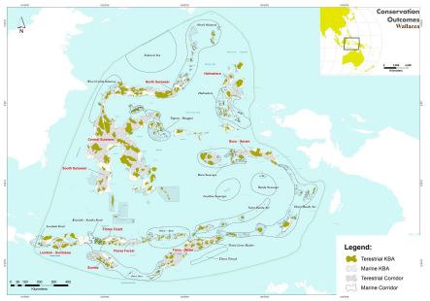
In addition to centre of biodiversity and endemism, Roberts et al (2002) also mentioned that Lesser Sunda held the 3rd rank in threats to endemism. This finding coherent with the study by CEPF (2014) where this region is a home to high number of globally threatened species where 5 marine corridors in Lesser Sunda are within the top 10 (Table 4).

Table 4. Marine corridors in Wallacea with hypothetical
and recorded numbers of globally threatened species
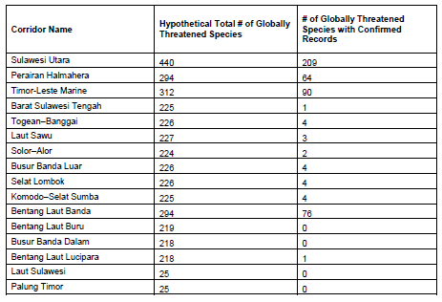

The effectively functioning Lesser Sunda seascape may also serve, among others, as a platform to develop a trans-boundary MPA network which functions as a whale sanctuary, connecting the marine mammal corridor from the Pacific Ocean to the Indian Ocean. The cetaceans in the Savu and Banda Seas, Raja Ampat and Timor Leste, within the Lesser Sunda region, may be genetically related to cetaceans in Papua New Guinea and Solomon Islands. This finding suggests that the area is important for both migratory and resident whales in the Coral Triangle region.

Lesser Sunda have an important area of endemism within the Coral Triangle. The total number of reef fish species is 1,783 which is particularly impressive because, presently, there is no other area of equal size that has as many species (Devantier L et all, 2008). By protecting this key spot of marine biodiversity, it can protect its richness owned by Lesser Sunda. It also means preserving the genetic biodiversity that is located in one of the marine hotspot in the world.

7. Available Data and Information

Lesser Sunda seascape can take advantage and be part of revitalization efforts of Coral Triangle Atlas (CT Atlas). CT Atlas provides a unique opportunity for any organization working in the Coral Triangle to share their data, and to create a growing, updated database for better management decisions and science including geographies of Lesser Sunda. It showcases maps that highlight the diversity and uniqueness of the Coral Triangle region including Lesser Sunda seascape and the pressing issues that are threatening this very important resource. It is an online Geographical Information System (GIS) database providing scientists, governments and NGOs with a view of spatial data at the regional scale. The efforts in designating and formalizing Lesser Sunda as priority seascape will be supported very much by the access to biophysical and socioeconomic information in spatially explicit provided by CT Atlas. At the same time, the process of data sharing will be able to complete the gaps reducing duplicate data collection, providing the most complete and most current data available and improving information flow and access to the Lesser Sunda sescape priority's best datasets.

CTI-CFF also has an established mechanism for restoring and accessing data including ones related with Lesser Sunda seascape. The CTI-CFF Monitoring and Evaluation System (M&E System) Operation Manual has been developed as a framework guide for the Regional Secretariat, the Technical Working Groups (TWGs) including Seascape Working Group in which Lesser Sunda seascape is currently discussed and prepared to be a priority seascape, the National Coordinating Committees (NCCs) and the implementing partners to stick with indicators for each of the five RPOA goals as well as the three higher level outcomes, to work in a flow in collecting, analyzing and reporting indicators against progress and to be adaptive in managing each TWG’s activities. The relevant data collection and transfer on Lesser Sunda resulting from CT M&E System, if it works properly, should be able to inform and be solid analytic basis in planning and justifying Lesser Sunda as priority seascape and other necessary decision-making form the field to the top.

A range of data and information on Lesser Sunda in Indonesia’s region is available, including the aspects of ecological, biophysical, sosio-economic, among others. These data are mostly generated for the needs of marine conservation, marine spatial planning, species protection, which are provided by central government, local government, and some non-profit organisations like The Nature Conservancy, World Wildlife Fund, Conservation International, and Wildlife Conservation Society.

Conclusion and Recommendation

Through the establishment of Lesser Sunda as priority Seascape, the CTI-CFF can build a consistent regional framework for sustainable management and a platform for future investment in the area. The priority seascape can also serve as a main umbrella vehicle integrating all other CTI-CFF five thematic RPOA goals’ activities. Functionally, the priority seascape will be able to provide a platform to coordinate various policies, laws, and regulations within the marine space such as navigation, fishing, mining, and traditional and cultural uses. Collaboration between the Government of Indonesia and Government of Timor Leste through the nomination of Lesser Sunda as priority seascape hopefully will facilitate an integrative approach among two countries to reach effective management of marine resources in the region. Only with effective management, ecological functions of the system can be maintained and bring economic benefits to the community.
This document is a step to trigger further data and information sharing among the two countries, especially ones from Timor-Leste that can complement the existing Lesser Sunda priority seascape working proposal prepared by Indonesia. Having Timor-Leste’s data and information in the document will enrich the substantive scientific basis and strengthen the justification for the seascape nomination. Based on solid and convincing proposal that fulfils all necessary requirements and guidelines provided in CTI-CFF’s Seascape General Model and Regional Framework for Priority Seascapes, the two neighbouring countries are expected to continue working together closely in the process of following the nomination procedure and steps. All of these will hopefully result in CTI CFF Council of Minister’s acceptance of Lesser Sunda priority seascape on November 2018 in its Ministerial Meeting in Manila.

Yulianto, I, SA Tarigan, P Ningtias, and A Hermansyah. 2015. Keterkaitan Biofisik antar Kawasan Konservasi Perairan, Pesisir, dan Pulau-Pulau Kecil di Provinsi Nusa Tenggara Barat: Bukti ilmiah pengembangan jejaring kawasan konservasi laut. Wildlife Conservation Society Indonesia Program. Bogor. 38 hal.
For more information see various Campaign Learning Reports prepared by RARE upon completion of Pride Campaign Programs in Komodo Marine National Park, Nino Konis Santana National Park, Gili Matra Marine Recreational Park, and Bumbang Bay Marine Tourism Park.
Form and type of cooperation between Government of Indonesia and Government of Timor Leste (https://www.kemlu.go.id/dili/en/Pages/Timor-Leste1.aspx) accessed on 23rd February 2018.
Huffard, C.L., M.V. Erdmann, T.R.P. Gunawan (Eds) (2012). Geographic Priorities for Marine Biodiversity Conservation in Indonesia. Ministry of Marine Affairs and Fisheries and Marine Protected Areas Governance Program. Jakarta- Indonesia. 105 pp.
Roberts, CM, CJ McClean, JEN Veron, JP Hawkins, GR Allen, DE McAllister, CG Mittermeier, FW Schueler, M Spalding, F Wells, C Vynne, abd TB Werner. 2002. Marine Biodiversity Hotspots and Conservation Priorities for Tropical Reefs. Science 295: 1280 - 1284
Allen G R. 2008. Conservation Hotspots of Biodiversity and Endemism fro Indo-Pacific Coral Reef Fishes. Aquatic Conserv: Mar Freshw Ecosyst 18: 541-556
Critical Ecosystem Partnership Fund. 2014. Ecosystem Profile: Wallacea Biodiversity Hotspot. 375 p.

